Email:clairenakilacc@gmail.com

clairenakila18

clairenakila#123

DLS005- CREATING AND DESIGNING PRESENTATION SLIDES

[Show or hide gridlines in Word, PowerPoint, or Excel - Microsoft Support](https://support.microsoft.com/en-us/office/show-or-hide-gridlines-in-word-powerpoint-or-excel-47b1189c-f867-479e-a208-34ee54055f6f)

[Work with gridlines and use snap-to-grid in PowerPoint - Microsoft Support](https://support.microsoft.com/en-us/office/work-with-gridlines-and-use-snap-to-grid-in-powerpoint-84ed7394-5b37-4326-b13d-60fbc845e096)

[How to add Gridlines in PowerPoint (PPT Shortcuts) - YouTube](https://www.youtube.com/watch?v=rWgOkHzhntU)

* [7 GREAT POWERPOINT PRESENTATION LAYOUTS](https://dict-ilcdb.castlms.com/api/externallink?uri=https%3A%2F%2Fsynapsiscreative.com%2F7-great-powerpoint-presentation-grid-layouts%2F&course_block_uuid=dc8d94d2-e772-4aeb-8a54-ead5e72279b0&course_uuid=8ce83fad-07e3-417c-81f3-3bee4dec5361&resource_uuid=018ed3d5-84ec-4935-a970-f14b84adc4d8)

[Layout Design: Types of Grids for Creating Professional-Looking Designs (visme.co)](https://visme.co/blog/layout-design/)

COLOR

[Color wheel - color theory and calculator | Canva Colors](https://www.canva.com/colors/color-wheel/)

[The basics of the color wheel for presentation design (Part I) - Presentitude –](https://presentitude.com/color-theory-part-1/)

* [How to Use a Color Wheel or How to Choose Colors!](https://dict-ilcdb.castlms.com/api/externallink?uri=https%3A%2F%2Fdimensionsthruart.com%2Fhow-to-use-a-color-wheel-or-how-to-choose-colors%2F&course_block_uuid=81ee8b51-d3d3-473e-b7c9-cb339e26b830&course_uuid=8ce83fad-07e3-417c-81f3-3bee4dec5361&resource_uuid=a290a258-5ac9-45ea-9aad-a7fa459974fe)

[How to Pick the Right Colors for Your Powerpoint Slides (youtube.com)](https://www.youtube.com/watch?v=N3hdg2-KP1A)

IMAGES

Here are some tips and things to avoid in adding images to your slides:

* 1. **Using pixelated or blurry images.** “If you find an appropriate image for your content but the quality is low, it is better to look for related images that can be used than jeopardize the quality of your slide design.
  2. **Tiny Images**. As much as possible, maximize the use of an image in your slide. High-quality images can make you play up the design on your slide. If you have texts or bullets, use half of the slide to text and half for your image.
  3. **Overuse of Visuals.** Squeezing all images just to fill up the empty space of the slide may not be good for your design. Choose a high-quality image that sums up the main theme of your slides.
  4. **Multiple pictures were arranged poorly.** There are instances that you need to add more than one image to your slide. Sometimes, we’re just adding them to fill the empty spaces. To arrange them properly, use gridlines or the default frames to your PowerPoint. These functions help presenters arrange visual elements properly.
  5. **Watermark images.** Can I ask a favor? Please do not use images that have watermarks on your slides. Using them without the permission of the owner is an infringement of copyright. If you would really like to use it for your presentations, either pay or ask permission from the owner.
  6. **Amputating people while cropping images.** Avoid cutting any body parts of the people in the images. Instead of cropping any body parts, minimizing the images can help make your slides better.
  7. **Badly stretched photos.**Even high-quality photos can be distorted when it is poorly stretched in a presentation. If your image has a different ratio to your frame, or if you use picture fill but the image gets distorted, here’s what you can do:
     + - * Click the stretched photo
         * Go to the Format tab on the PowerPoint ribbon
         * Under the Crop dropdown menu, choose the Fill option
         * It will resize the image but the original ratio remains
         * Drag your photo to adjust the portion of the area
         * Choose a white or similar background of the image

These are some of the things you can do to avoid distorting your images in your presentation.

SAMPLE PRESENTAION





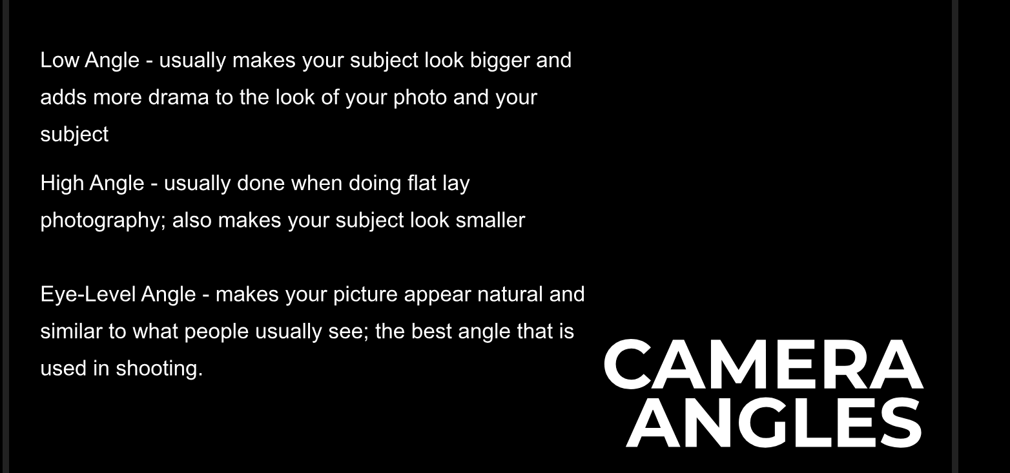

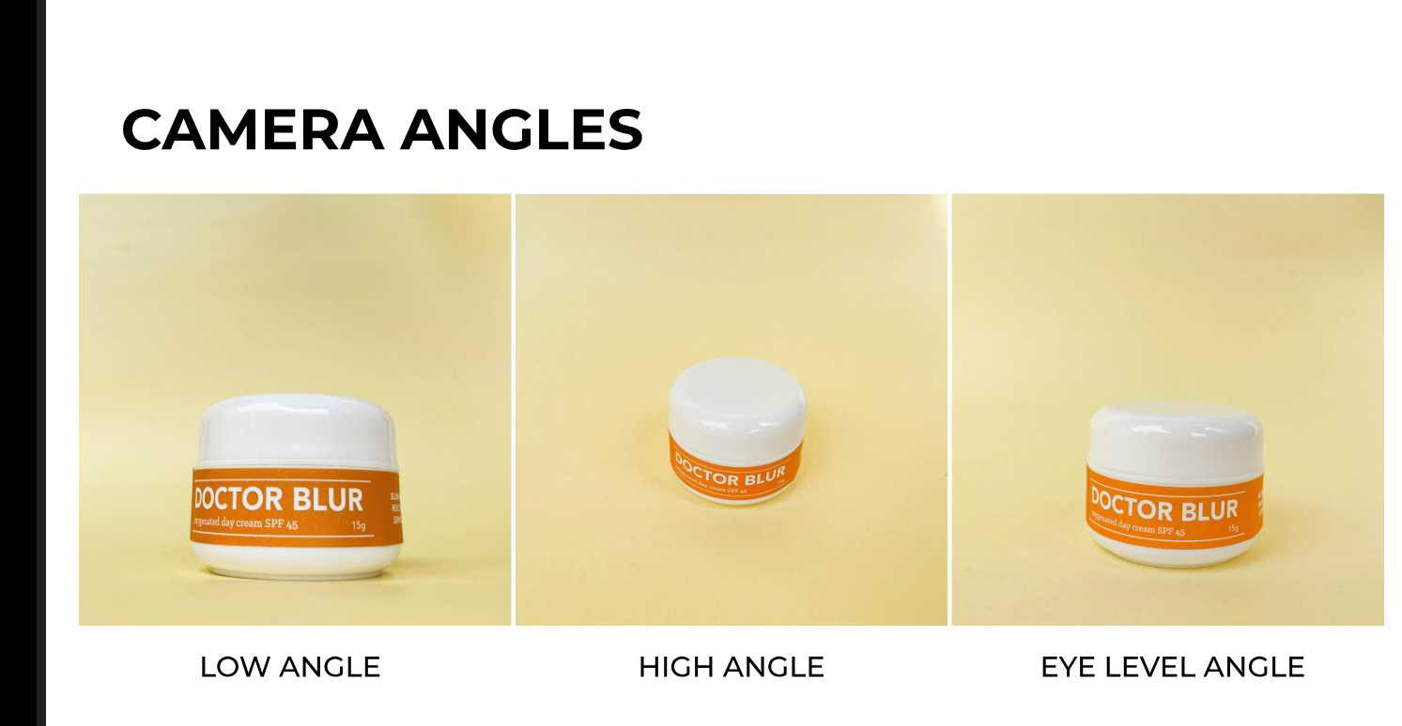



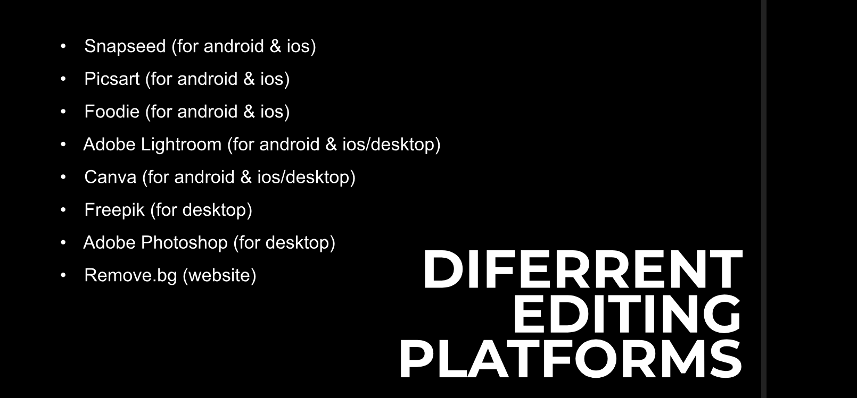



VIDEOS

What should be considered when incorporating videos in your slides?

* **Keep your videos short, it should be under 3 minutes.** These can help you maintain the attention of your audience to your message. Remember, do not let any visual aid replace you as a presenter.
* **Be purposeful in choosing video content.** Make sure that the videos are relevant to your topic.
* **Check the sound system in the venue or the settings in your virtual meeting room.**
* **Don’t rely on videos alone.** Again, your video should not replace you as a presenter. Make your discussion complements in the video or vice versa.

You may refer to these links to know some ways to present videos in virtual meeting rooms:

[Present with your video beside your PowerPoint slides in Microsoft Teams or Zoom (youtube.com)](https://www.youtube.com/watch?v=rKDKniBmwe0)

[Present with your video beside your PowerPoint slides in Microsoft Teams or Zoom (Windows) | Think Outside The Slide](https://www.thinkoutsidetheslide.com/present-with-your-video-beside-your-powerpoint-slides-in-microsoft-teams-or-zoom/)

[6 Options for Presenting PowerPoint Slides in Zoom | Think Outside The Slide](https://www.thinkoutsidetheslide.com/4-options-for-how-to-present-a-powerpoint-slide-show-in-a-zoom-meeting/)

DESIGN TEMPLATE

There are lots of available templates in **MS PowerPoint** and **online**. But most of the time, companies and organizations use **centralized templates for presentations**. Centralized templates can increase **productivity**, **lessen the hassle to the employees**, and retain the branding of the organization.   Therefore, it is essential that the templates used are well-built.

**What should be considered in preparing a template?**

* + Identify the elements that are purely decorative versus those that are the truly essential visual brand elements. For the template, use the essential elements only.
  + Identify the varying types of content that your company uses to convey the message.
  + Content should not bounce from slide to slide to avoid confusion to the audience.
  + Titles and bullet copy should appear in the same locations (unless you’ve intentionally designed it that way to serve a purpose).

**“Employees contribute to the impression your brand leaves. Arm them with a good template to steward it well.” - Nancy Duarte**

Here are some of the links that will help you prepare your templates:

[Create and save a PowerPoint template - Microsoft Support](https://support.microsoft.com/en-us/office/create-and-save-a-powerpoint-template-ee4429ad-2a74-4100-82f7-50f8169c8aca)

[Six ways to build PowerPoint templates your colleagues will love (templafy.com)](https://www.templafy.com/blog/building-powerpoint-templates-colleagues-will-love/)

[Centralized PowerPoint Presentation and Slides | SlideTeam](https://www.slideteam.net/tag/centralized-powerpoint-templates-ppt-slides-images-graphics-and-themes)